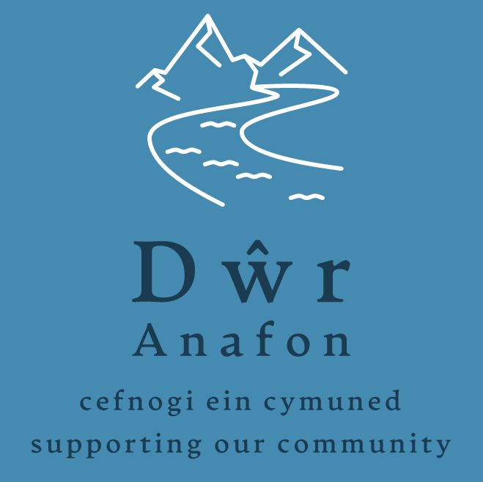

Application Form for Groups

Make sure you have read the Guidelines for Applicants before you complete this application.
Please write / type clearly in black or blue ink.
Please answer every question. Where the question is not appropriate to your organisation or project please write Not Applicable (N/A)

For Office Use Only:
Reference number..................... Date of receipt.........................

Section 1: About Your Organisation

Name of organisation

Contact person’s name &position in the organisation

Address of your organisation / key contact person responsible for the project | Post Code:
Contact details of person responsible for the project | Home phone:  Mobile:  Other:  E-mail address:
Please describe your organisation type | Charity number (if applicable) …………………………  Company number (if applicable)………………………….
Is membership of your organisation / project team open to anyone who wants to join?

Yes No

If No please explain why?

How many paid staff do you employ?  How many volunteers do you have? | Full time: Part time:  Volunteers:

Section 2: About your project

Please describe your proposed project – (What are you going to do?)

Which of the charities objectives will be fulfilled by this project – (State all that are applicable)

Who is on your project team?
What benefits will your project bring to the community?

What evidence do you have that the project has the support of the community?

How will this funding help you to achieve your goal?

__________________________________________________________________________________

Do you, or anyone else involved in making this application, have a connection to any Dwr
Anafon trustee (current trustees are all listed on our website) who will potentially be involved
in making a decision on the application?

Yes No

If you have answered “Yes” please describe the nature of this connection.

Will the governance of the project be passed to another body on completion of the project?

Yes No

If yes, please state who will take on governance of the project and provide evidence that they are willing to do so

If no, who will be responsible for ongoing governance:

What is the planned project start date?  What is the planned project completion date? | / /  / /

Section 3: Project Financial Details

Expenditure |  | Cost  £ | VAT  £ |  | Total  £
Total Project Costs =

Have you applied for funding from elsewhere?  If the answer is No, please provide reason. | Yes No
Please list any other funding bodies that have been contacted and the amount of money requested |  |  |  | £
 |  |  |  | £
 |  |  |  | £
 |  |  |  | £
Grant aid sought from Dŵr Anafon  NB Groups may only apply once in any 12 month period and maximum grant amount is £12, 000 |  | £

Is your Organisation registered for V.A.T.? | Yes No  If yes; you will be expected to reclaim V.A.T. on your project and any grant paid will exclude the V.A.T. element

Section 4: Project Check List

The following documents should be included as part of your application, if applicable

- Copy of organisation constitution (or other governing document)

- Two written quotes or estimates

- Copy of last available accounts

- Bank Statement

- Evidence/letters of community support for project

- Copy of planning permission or listed building consent

- Evidence of adoption of project by another body eg ARC

To be completed by a representative of the organisation/group:

I confirm that all the information on this form is true and correct.

Representative’s name: | Position:
Phone No.: | E-mail:
Signature: | Date:

DATA PROTECTION
Dŵr Anafon will use the information you provide, including personal information, for the purposes of dealing with your grant application only. Data will be securely stored for 7 years from the date of receiving the application or the date the project is completed, whichever is later. It will then be destroyed securely.

We confirm that, if our application is successful, Dwr Anafon can publicise the project, including the amount awarded

For further help or advice, or to return your completed Application Form and supporting documents please contact:

Dŵr Anafon, Yr Hen Felin, Abergwyngregyn, Llanfairfechan, LL33 0LP

or

info@dwranafon.co.uk

The following organisations can provide independent help and advice regarding grant application, including advice on match funding:

http://mantellgwynedd.com email: ymholiadau@mantellgwynedd.com

http://cvsc.org.uk email: mail@cvsc.org.uk

